**Explore business report types**

**Introduction**

With Adventure Works due for its quarterly performance review across all departments, your boss requests a clear, concise, and visually appealing set of analytics reports. You know the request isn't just about numbers—it's about crafting a story of data insights that speaks directly to the company's needs. Understanding reports in Microsoft Power BI can empower you to transform raw data into strategic narratives with the support of visualization.

In this reading, you'll learn about different types of business reports in Power BI and their component elements, including the visualizations and insights you can represent within the reports. You'll gain insight into how you can use Power BI to craft strategic narratives from raw data from different business departments.

**The structure of a Power BI report**

A Power BI report is a multi-perspective view of a dataset, complete with visualizations, metrics, and insights represented in different ways. These reports are highly interactive and customizable. A report typically contains multiple pages, each filled with visualizations such as charts, graphs, or maps, as well as other report elements relating to some aspect of the dataset. Reports are vital to monitor, analyze, and communicate key performance indicators, trends, and insights. With its robust reporting capabilities, Power BI makes reporting efficient and insightful.

**Types of business reports**

Let's explore some commonly used reports you can build within Power BI for different business domains, including the sales, marketing, finance, and human resources (HR) departments.

**Sales reports**

Sales reports are pivotal tools for any organization, providing insights into the sales team's performance. Sales managers, directors, and executives typically use sales reports. These reports enable businesses to keep track of revenue, identify top-selling products, understand seasonal trends, measure against sales targets, and gauge the overall health of the company's sales efforts. They can help motivate the sales team and support the team in identifying areas for improvement, setting realistic sales forecasts, and aligning sales strategies with company goals.

In a complex organization like Adventure Works, sales reports are indispensable in coordinating sales efforts across regions and product lines. Sales reports in Power BI can contain a range of visuals with different functions. To give you an idea, a line chart could display monthly sales trends, allowing for easy identification of peak sales periods.

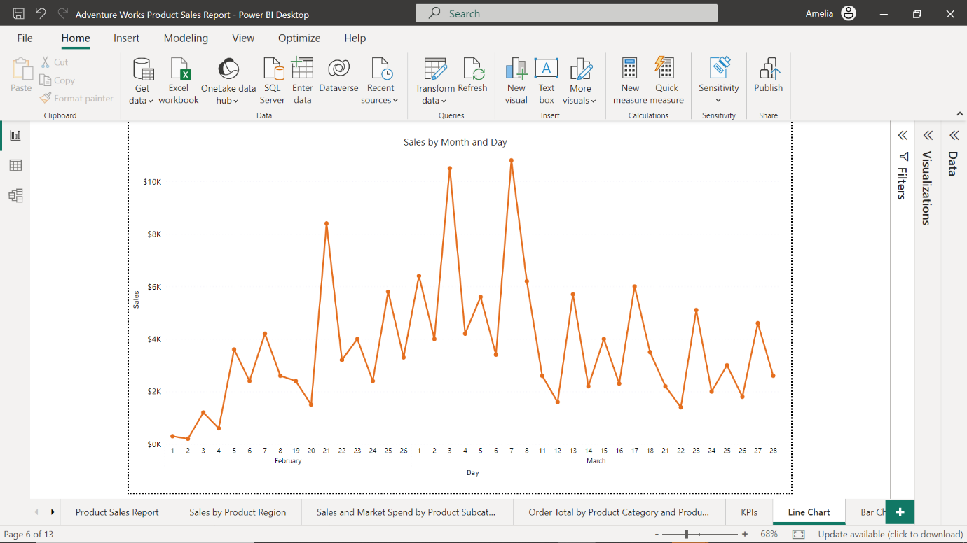

You might use a bar or column chart to compare sales performance across different regions or product categories.

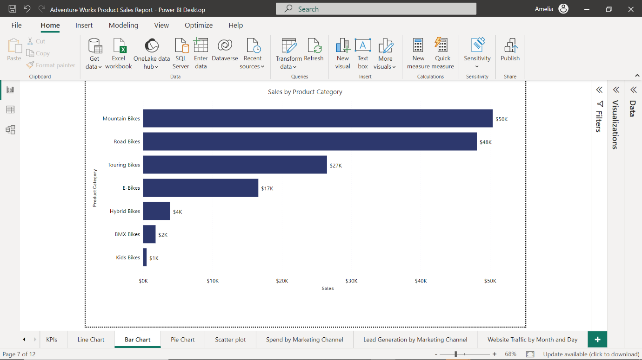

Finally, a pie chart could provide a breakdown of sales by each salesperson, highlighting top performers.

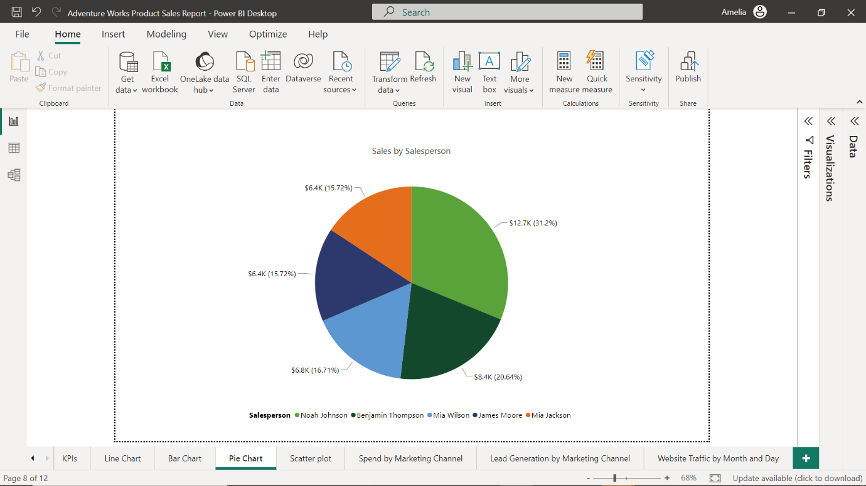

**Marketing reports**

Marketing reports are essential for tracking and analyzing the performance of marketing campaigns. Typically used by marketing professionals, such as managers, executives, Search Engine Optimization (SEO) analysts, and social media coordinators, marketing reports help marketing teams understand their audience, optimize their strategies, and demonstrate the value of their work to stakeholders. These reports provide valuable insights into customer demographics, behavior, and preferences and can be used to measure return on investment (ROI) for various marketing strategies.

Suppose you create a marketing report for Adventure Works. You might use a line chart to track website traffic over time.

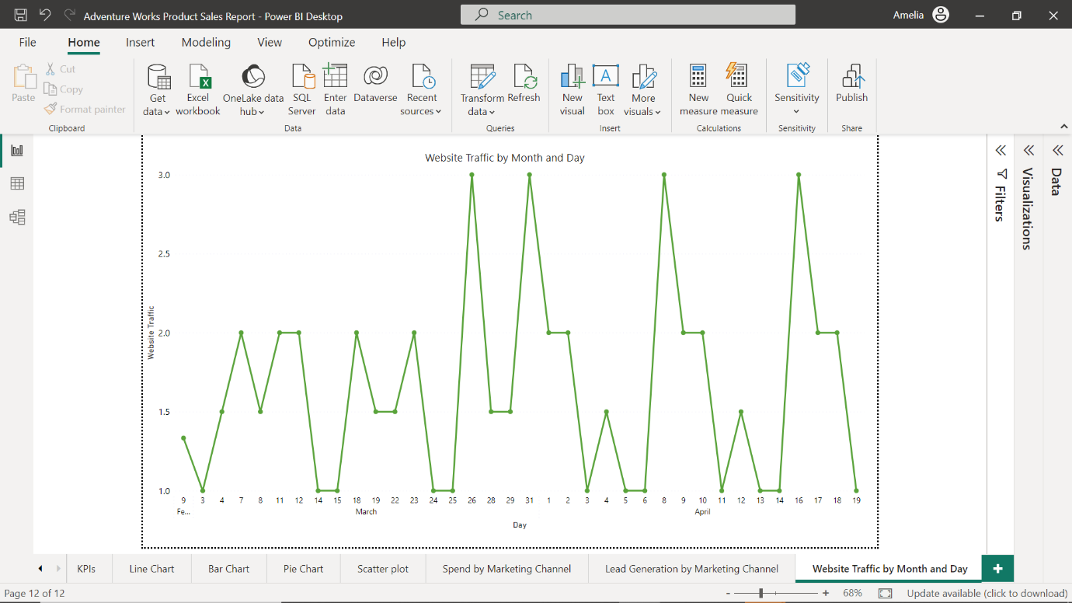

A bar chart could compare lead generation from various marketing channels to determine which channels are performing well in generating customer interest, engagement, and sales, and help the marketing team adjust marketing and sales strategies accordingly.

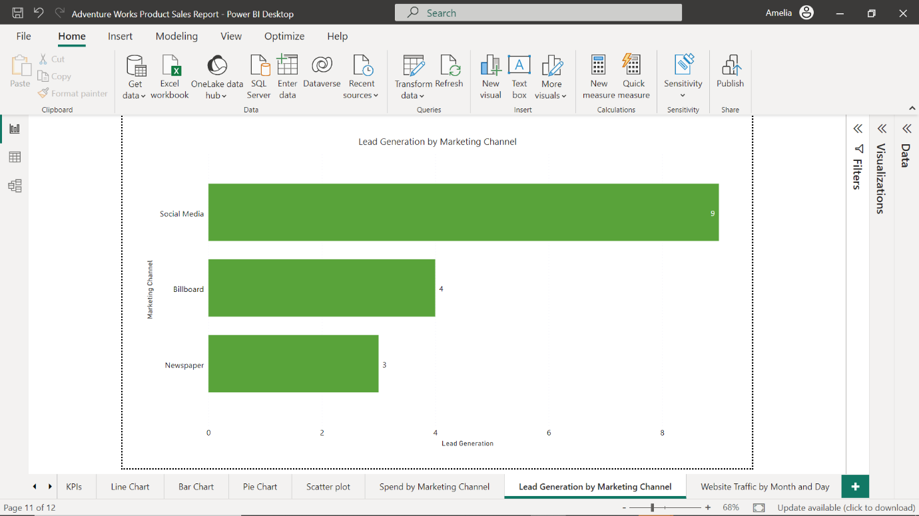

To gain further insight into lead performance, you could include a pie chart that visualizes the distribution of marketing spend across different channels.

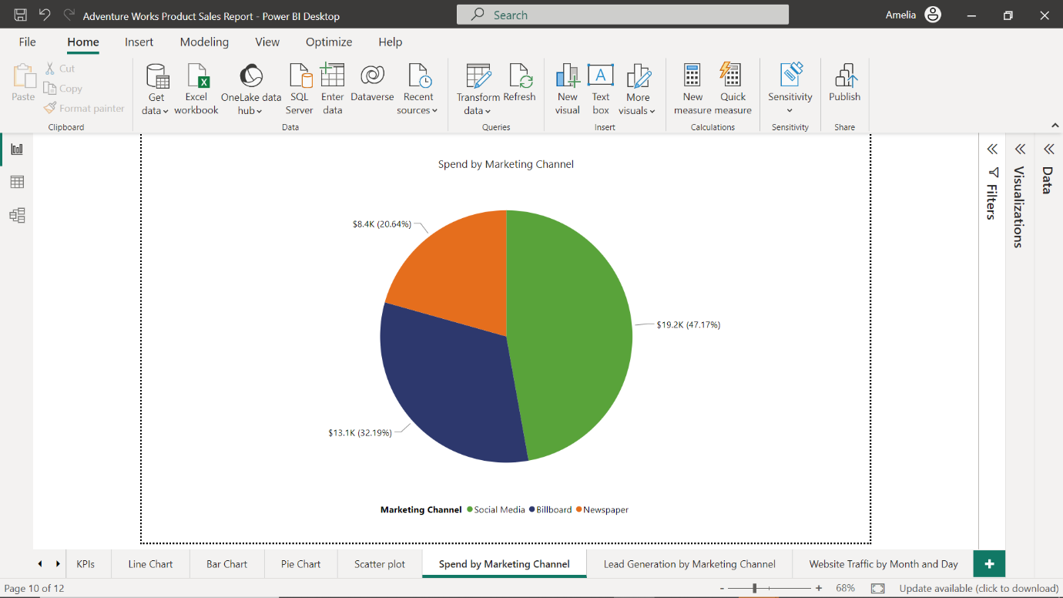

You could also use a scatter chart to analyze the correlation between marketing spend and lead generation.

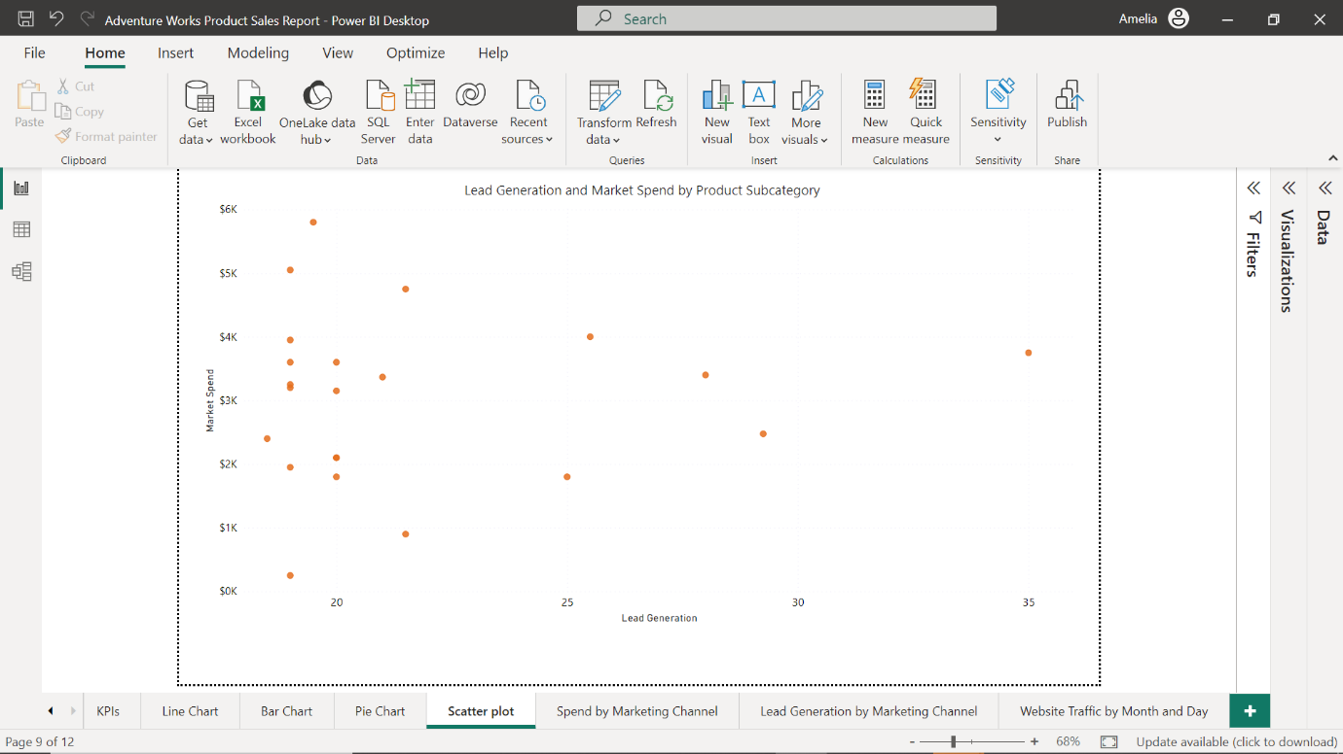

**Financial reports**

Financial reports are fundamental to any business. They provide a detailed picture of the company's financial health, tracking metrics like revenue, expenses, profits, and cash flow. Financial analysts, controllers, Chief Financial Officers (CFOs), and other executives use financial reports. These reports are crucial for making informed financial decisions, planning for growth, ensuring regulatory compliance, and communicating with stakeholders. They help monitor the company's financial performance, plan budgets, evaluate the profitability of different business units, and assess financial risks and opportunities.

A financial report for Adventure Works could use a line chart to track revenue and expenses over time.

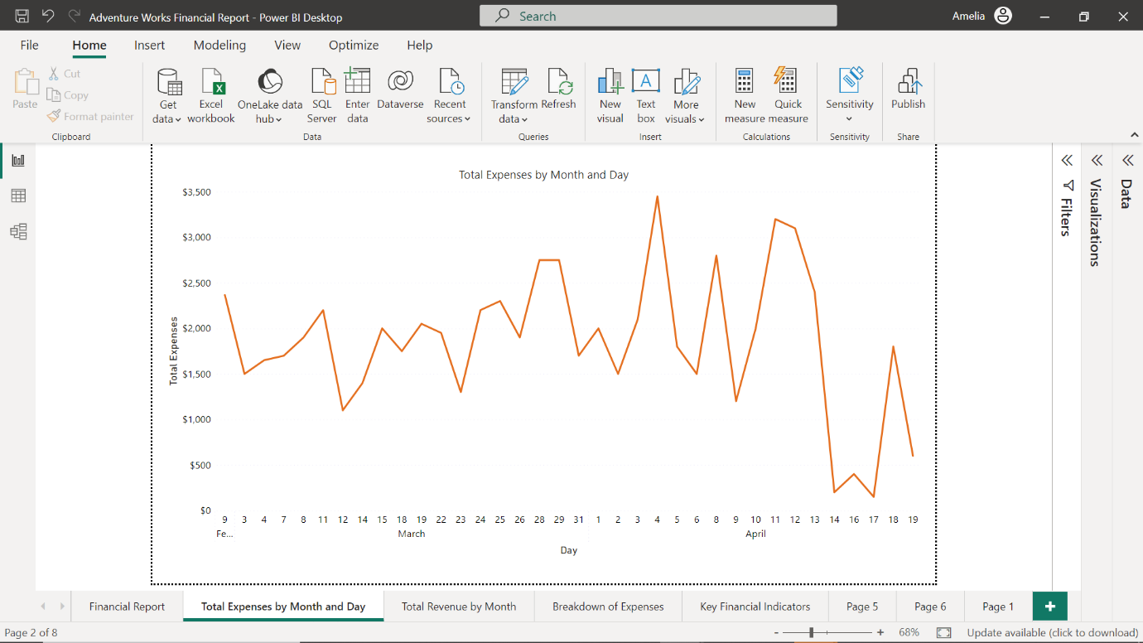

You could use a waterfall chart to illustrate how different revenue and expense categories contribute to the overall net profit.

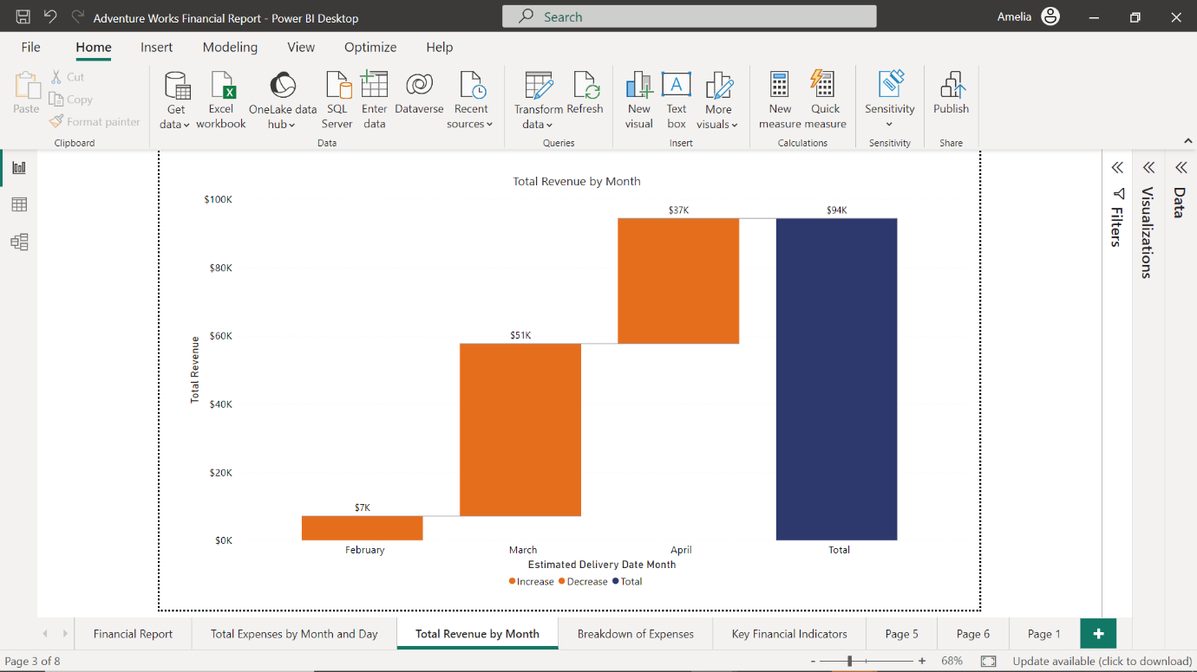

Including tables might be useful to provide a detailed breakdown of expenses.

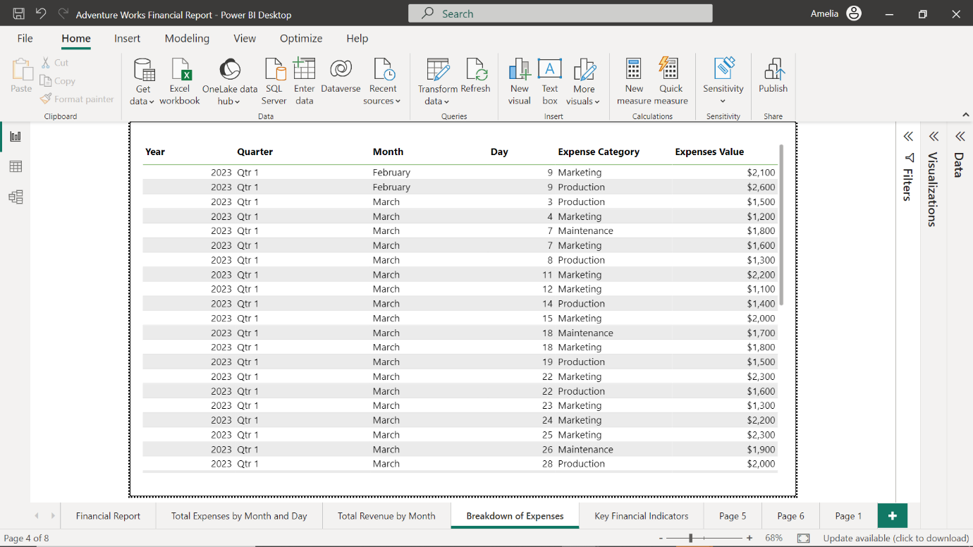

You could also incorporate card visuals to display key financial indicators like gross profit margin or return on assets.

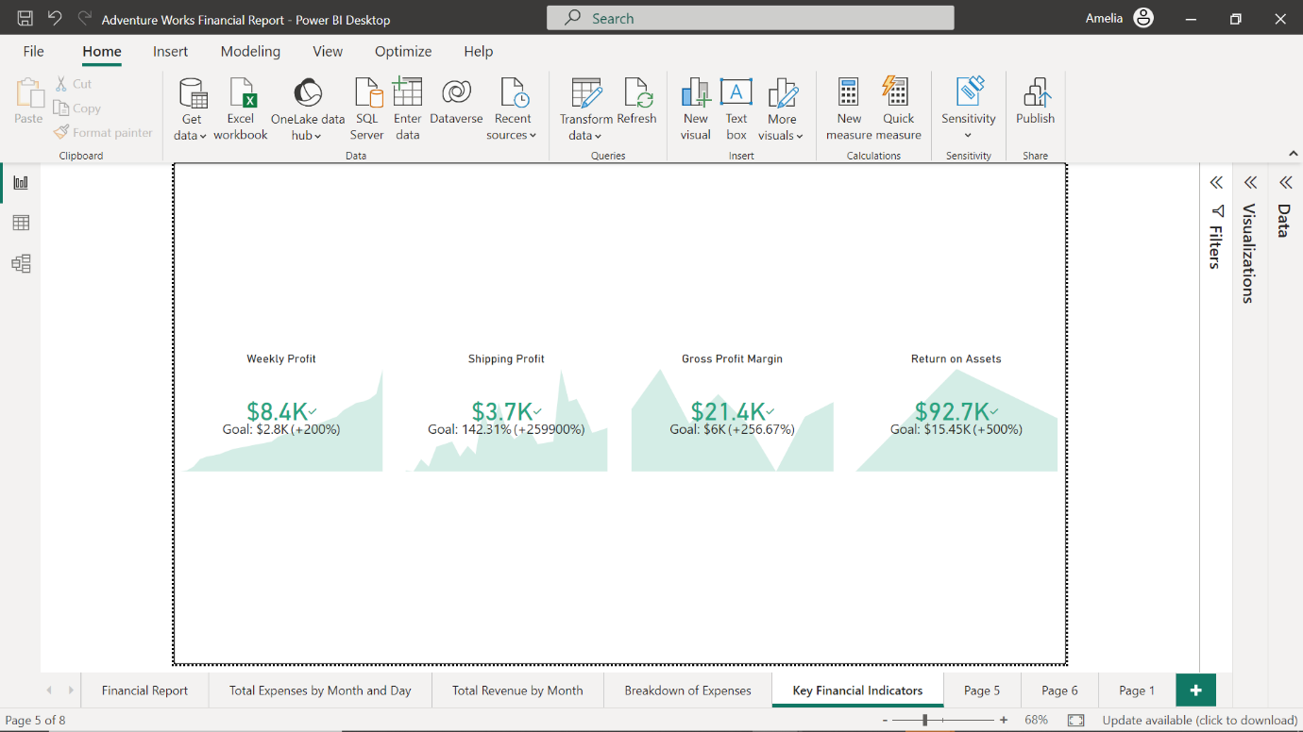

**Human Resources (HR) reports**

HR reports are crucial in managing a company's most important asset—its people. They provide insights into employee demographics, recruitment, turnover, performance, satisfaction, and more. HR managers, recruiters, performance analysts, and executives typically use HR reports. They can support various HR functions like recruitment, retention, performance management, diversity and inclusion, and strategic workforce planning.

You could employ a column chart in an HR report for Adventure Works to visualize the number of employees in each department.

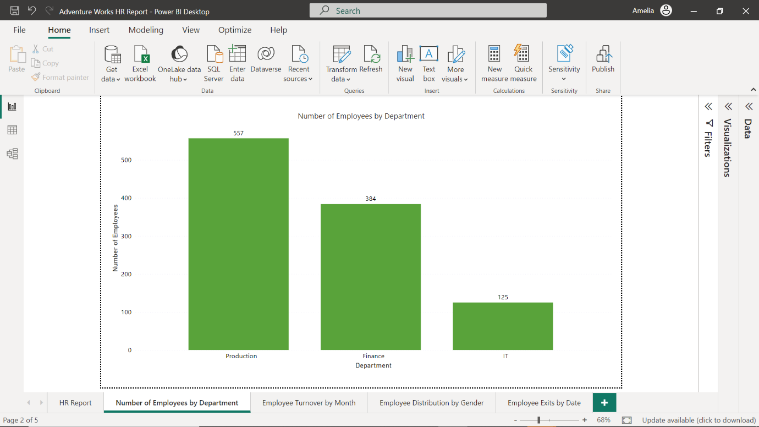

You could use a line chart to track the employee turnover rate over time, to help stakeholders identify any trends in employee attrition (the rate at which employees leave a company over a given period) and factors impacting turnover, as well as inform employee recruitment and retention strategies.

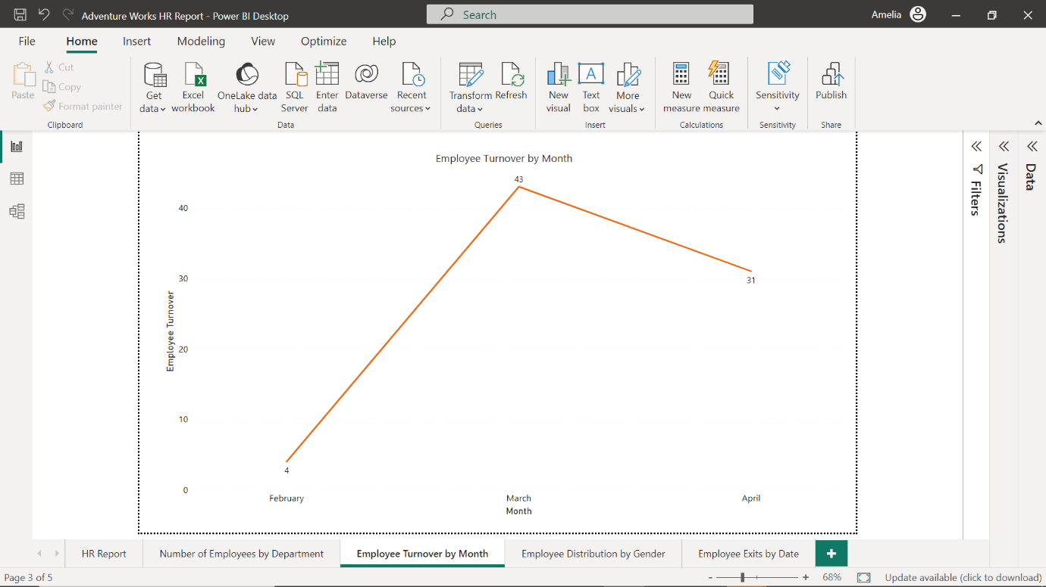

A pie chart could display the distribution of employees by gender or ethnicity, supporting diversity initiatives.

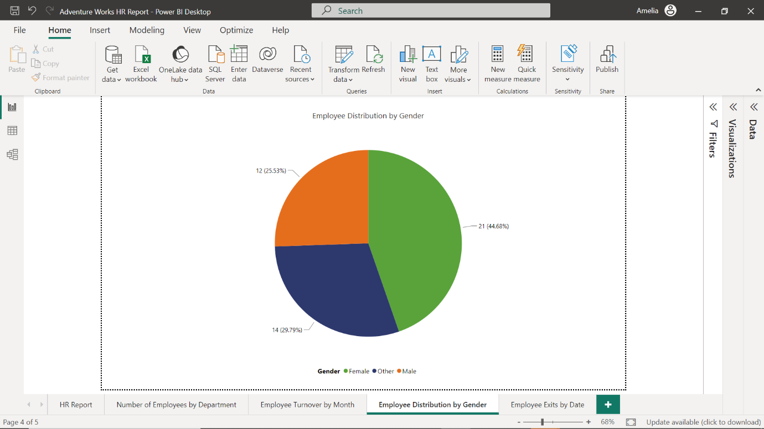

You could also include a table to provide detailed data on new hires or exits. Power BI's advanced features, like Power Query, can also clean, transform, and analyze data, allowing for more sophisticated HR analytics.

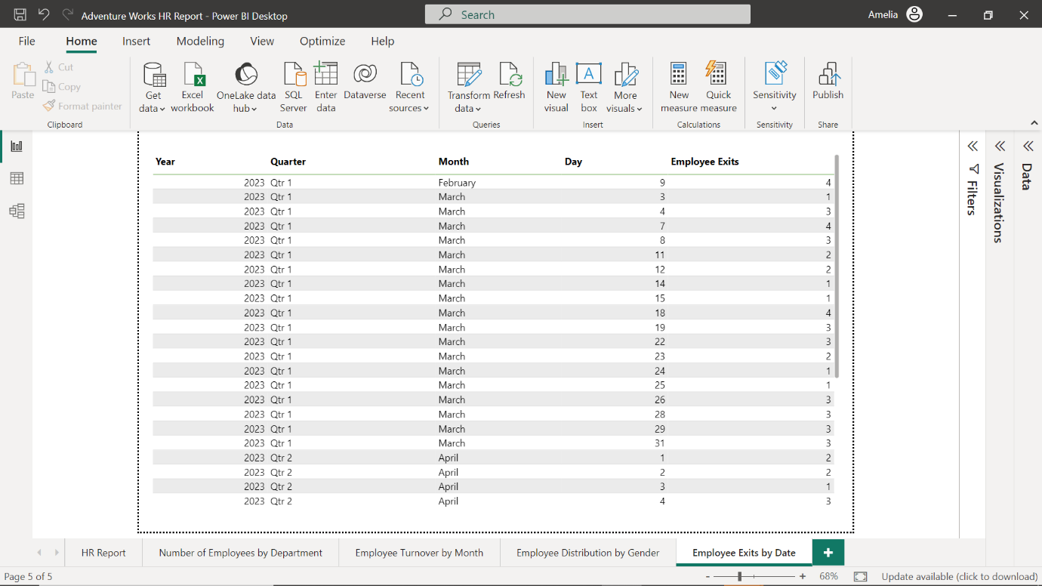

**Conclusion**

Whether it's for sales, marketing, financial, or HR reports, Power BI's reports are dynamic, transformative tools that empower you to transform even the most intricate raw data into compelling business insights. With Power BI, you're not just creating reports; you're weaving data into narratives with engaging visuals that can influence decisions, inspire action, and impact an organization.

**Report Editor in Power BI**

**Introduction**

Imagine you're a data analyst at Adventure Works, a multinational manufacturing company specializing in bicycles and accessories. You've just received a wealth of raw data–sales figures, purchasing details, human resource data, and more–and you're enthusiastic to turn this data into actionable insights. Senior management is counting on you to deliver a compelling, easily digestible report by the end of the week. Sounds overwhelming, right? Well, not if you're using Microsoft Power BI's **Report Editor**!

In this reading, you will discover the layout, individual components, and core functionalities of Power BI's **Report Editor**, including the **Ribbon**, **Report Canvas**, and its various panes like **Filters**, **Fields** (or **Data**), and **Visualizations**. You'll delve into each UI element and how they contribute to your data analysis and report creation process.

**Introduction to the Report Editor**

The **Report Editor** in Power BI is a treasure trove of features and elements, each with its unique purpose and advantages. This is where you'll spend most of your time converting raw data into meaningful visual stories. The real beauty of the **Report Editor** lies in its intuitive design that caters to users of all skill levels. If you're just starting out in the data world, the drag-and-drop features and easy-to-navigate interface help lower the entry barrier. Let's explore some of its core functionalities.

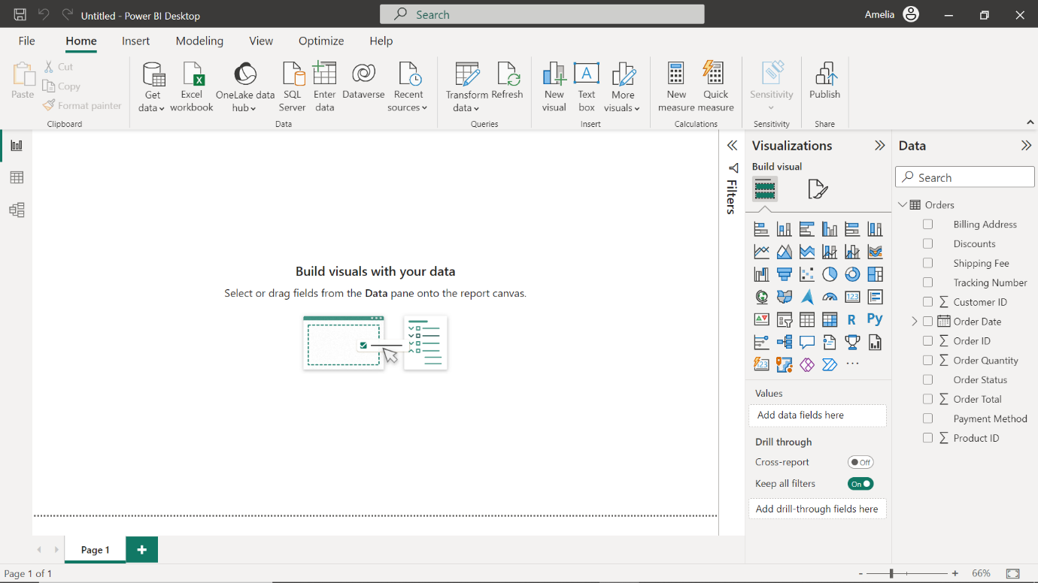

**Ribbon**

The **Ribbon** is where you have all your high-level command options. The **Ribbon** can be compared to the dashboard of a car, offering control over your entire project. You can save your project, change your report view, or even publish it to Power BI Service. If you're a technical assistant, you may often use the Insert option to bring text boxes, images, or even new pages to the report. The **Ribbon** is a highly versatile tool, allowing you to manipulate your report on a macro level.

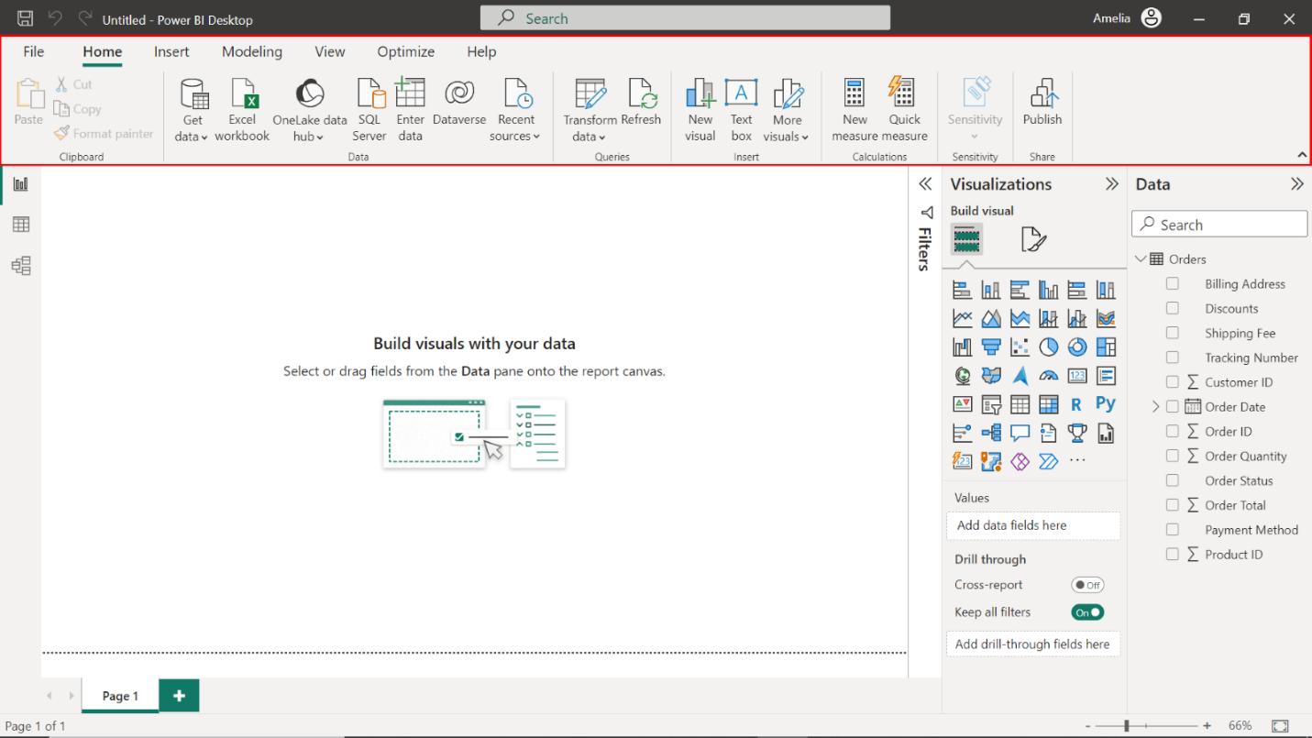

**Report Canvas**

The **Report Canvas** is your stage; this is where your performance happens. All the dragging and dropping of fields and visuals you do end up here. It's a blank slate that you populate with your data narratives. This area grants you the ability to organize multiple visuals in a cohesive layout, providing real-time, dynamic updates. The **Report Canvas** is your workspace to experiment, move things around, zoom in and out, and determine how your report is shaping up.

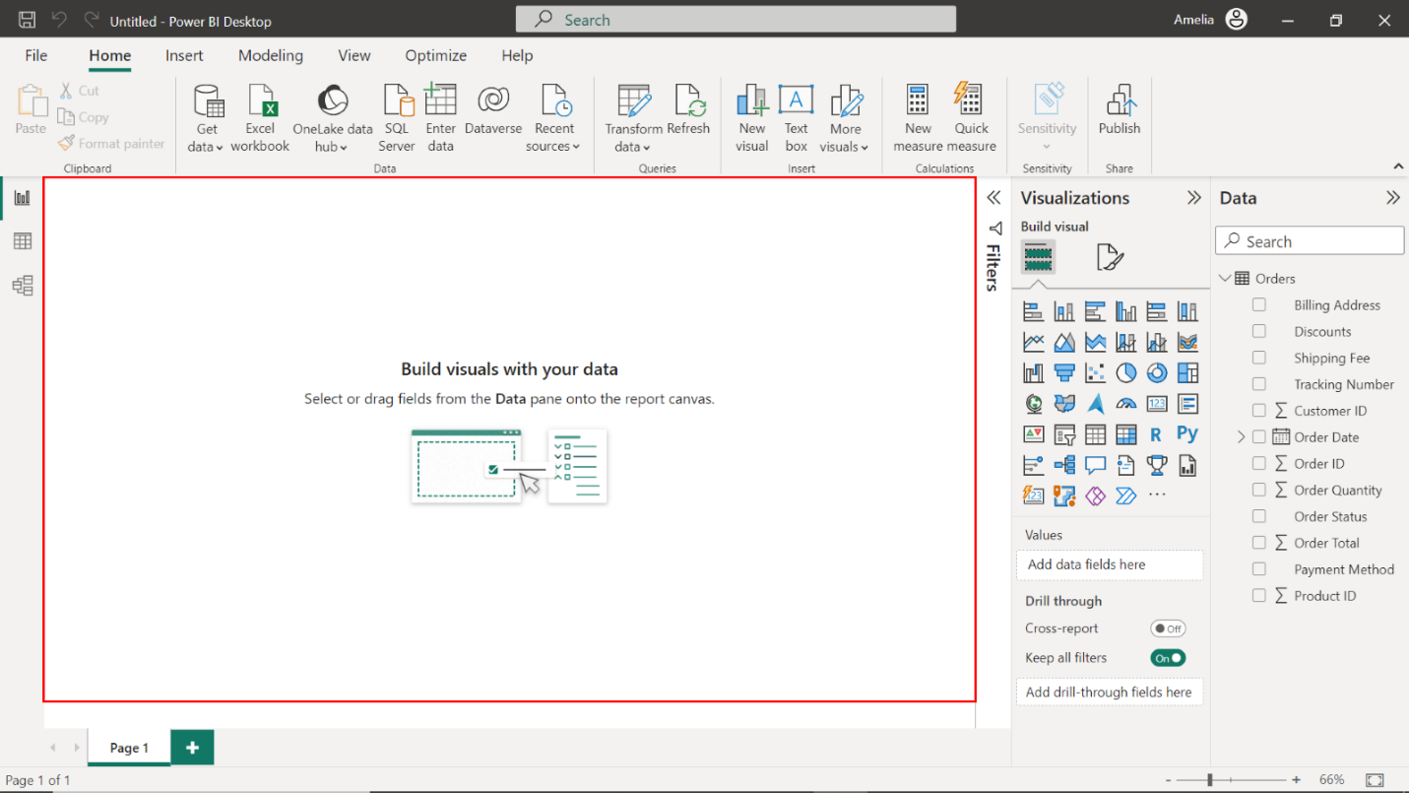

**Report Editor panes**

Three panes are visible when you first open a report: **Filters**, **Visualizations**, and **Fields** (or **Data**). The first two panes, **Filters** and **Visualizations**, control how your visualizations appear, including type, colors, filtering, and formatting. The last pane, **Fields** (or **Data**), manages the underlying data in the visualizations. Let's dive into each of these panes further.

* **Filters** pane: The **Filters** pane is your laser-focused magnifying glass. In a large-scale dataset like what Adventure Works would have, not all data may be relevant for every report. Maybe you need to explore only the Shipping Times for the last quarter for an executive report. To accomplish this, you could apply a filter only to pull that particular data, ensuring your report is targeted and meaningful. Using the **Filters** pane, you can view, set, and modify persistent filters to your reports at the page, report, drill-through, and visual level. You can do ad-hoc filtering on report pages and visuals by selecting elements of the visuals or by using tools like slicers.

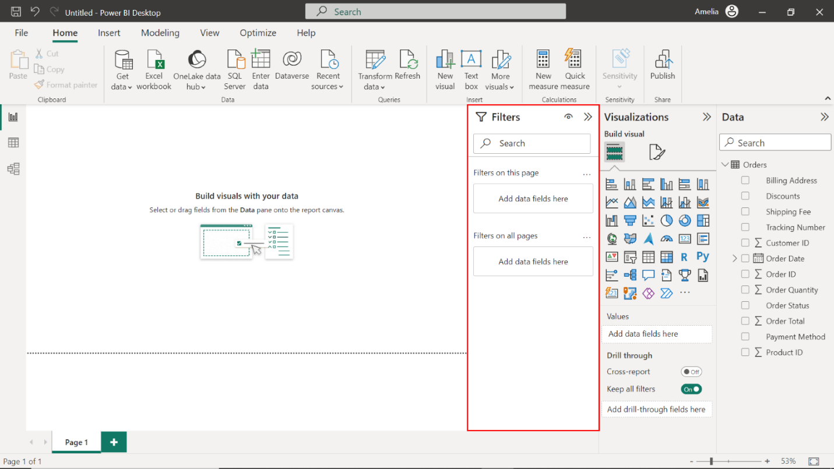

* **Fields** or **Data** pane: When you load data into Power BI, whether it's from an Excel sheet, AzureSQL database, or any other source, those data fields appear in the **Fields** pane on the right-hand side of your screen. **Note:** The **Fields** pane is also referred to as the **Data** pane or **Data** section, and the terms may be used interchangeably. Think of this pane as your ingredient list when cooking a complex dish. Using Adventure Works as an example, you may have different tables or datasets related to **Products**, **Sales**, **Employees**, and so on. The **Fields** pane is neatly organized to help you quickly find the columns you need. Fields can be as varied as **Product ID**, **Monthly Revenue**, **Employee Name**, and more. Dragging and dropping these into your **Report Canvas** helps you generate the visuals.

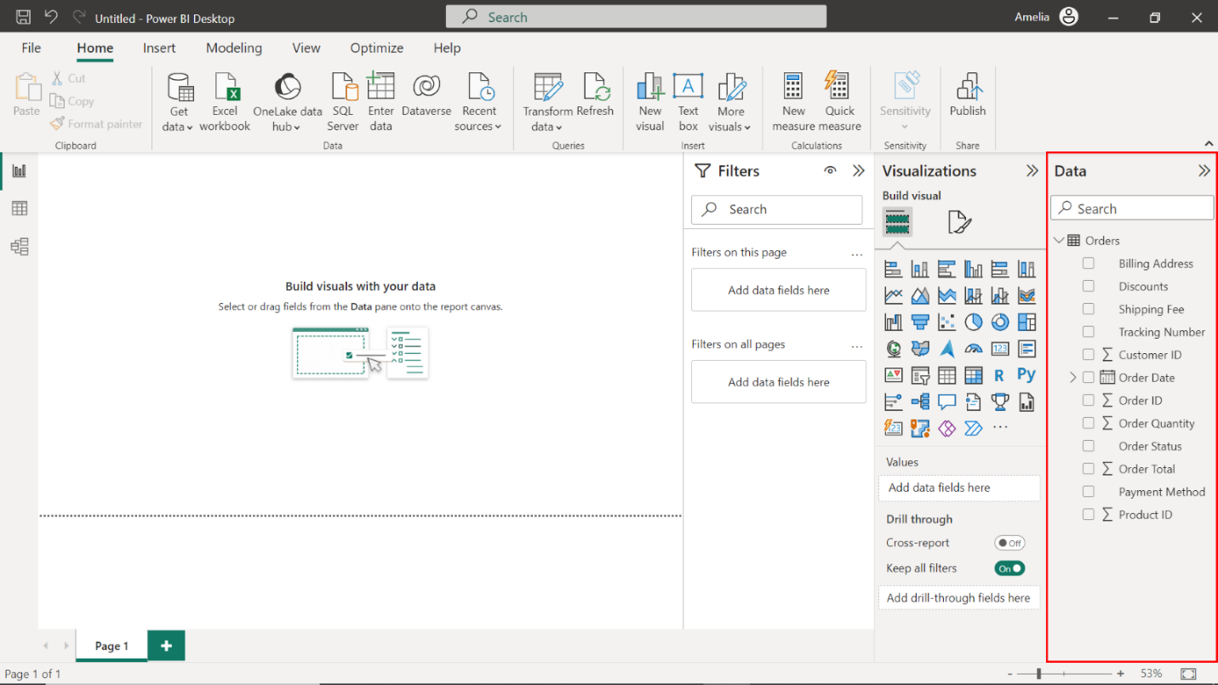

* **Visualizations** pane: On the left of the **Fields** or **Data** pane is your **Visualizations** pane. If the **Fields** or **Data** pane is your list of ingredients, then the **Visualizations** pane is your set of kitchen tools. Here, you'll find a variety of chart types like bar graphs, pie charts, tables, and even complex visuals like waterfall or funnel charts. You can also modify each visual's properties, such as colors and labels, to, for example, better align with Adventure Works' corporate branding guidelines. If you start building a visualization by selecting fields without selecting a visualization type first, Power BI picks the visualization type for you. You can keep Power BI's selection or change the type by selecting a different icon.

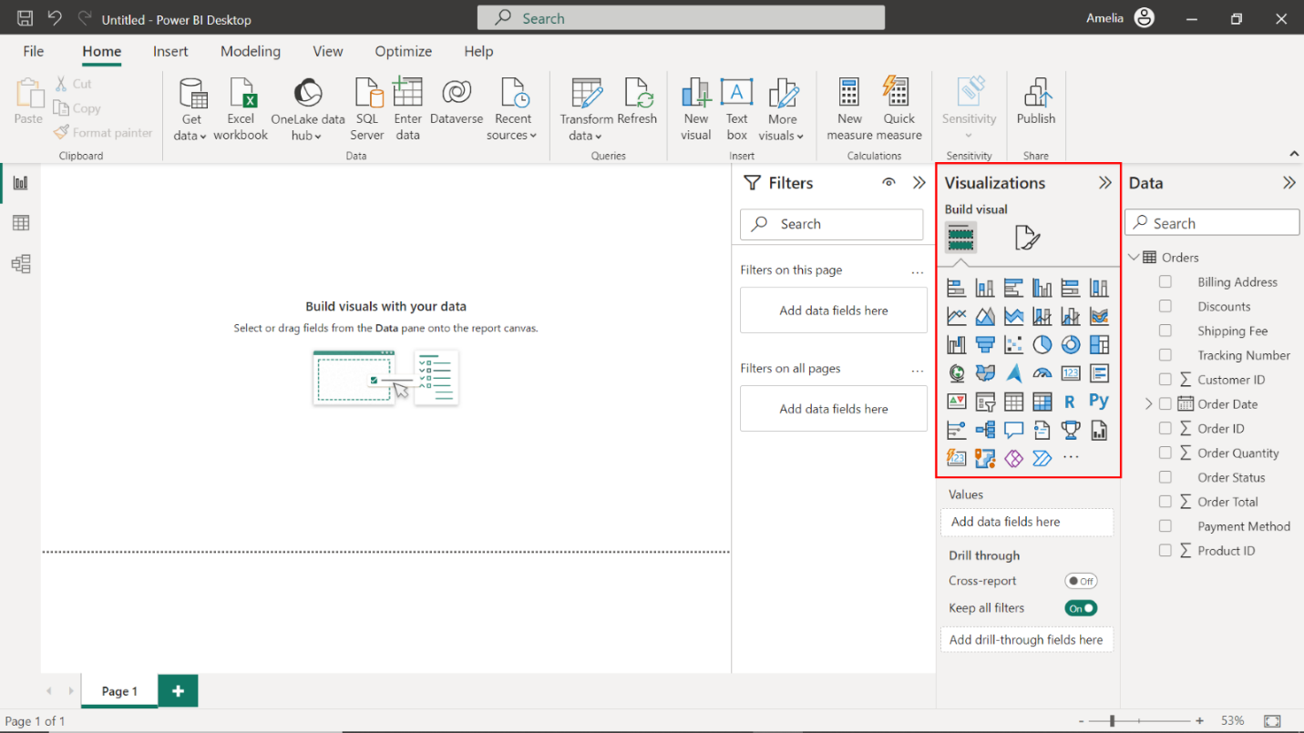

**Conclusion**

This reading taught you about the key UI elements in Power BI's Report Editor, including the Ribbon for high-level command options and the **Report Canvas**, where you arrange your visuals. You discovered the functionalities and locations of the **Filters** pane for targeted reporting, the **Fields** or **Data** pane for organizing your data, and the **Visualizations** pane for selecting the appropriate charts or graphs. Although you've touched upon the basics of the Report Editor in this reading, understanding its full scope and functionalities is crucial for your data analysis and reporting skills. Rest assured, you will be delving deeper into the capabilities and features of the Visualizations pane in this course.

**Visualizations pane**

**Introduction**

Making sense of numbers from multiple data sources can be challenging for analysts and stakeholders alike. As a data analyst, you can use Microsoft Power BI’s Visualizations pane to transform raw data into easy-to-understand insights that stakeholders can guide business decisions with. This reading introduces you to the structure, function, and uses of the Visualizations pane. You'll explore the three main sections of its user interface, discovering how to use this tool to deliver engaging visuals and critical insights to decision-makers.

**Visualizations pane**

Visualization is a powerful tool in data analysis because our brains process visual information much faster than text-based data. The **Visualizations** pane in Power BI enables you to convert complex datasets into visually appealing insights, in turn enabling easy data comprehension for decision-makers. Located on the right-hand side of the Power BI desktop, the **Visualizations** pane is the toolbox for your data visualization process. You can use it to create, modify, and manage visual elements such as charts in your data analytics. Let’s explore the three main sections of the **Visualizations** pane: the **Format** section, the **Data** section, and the **Analyze** tab.

**Format**

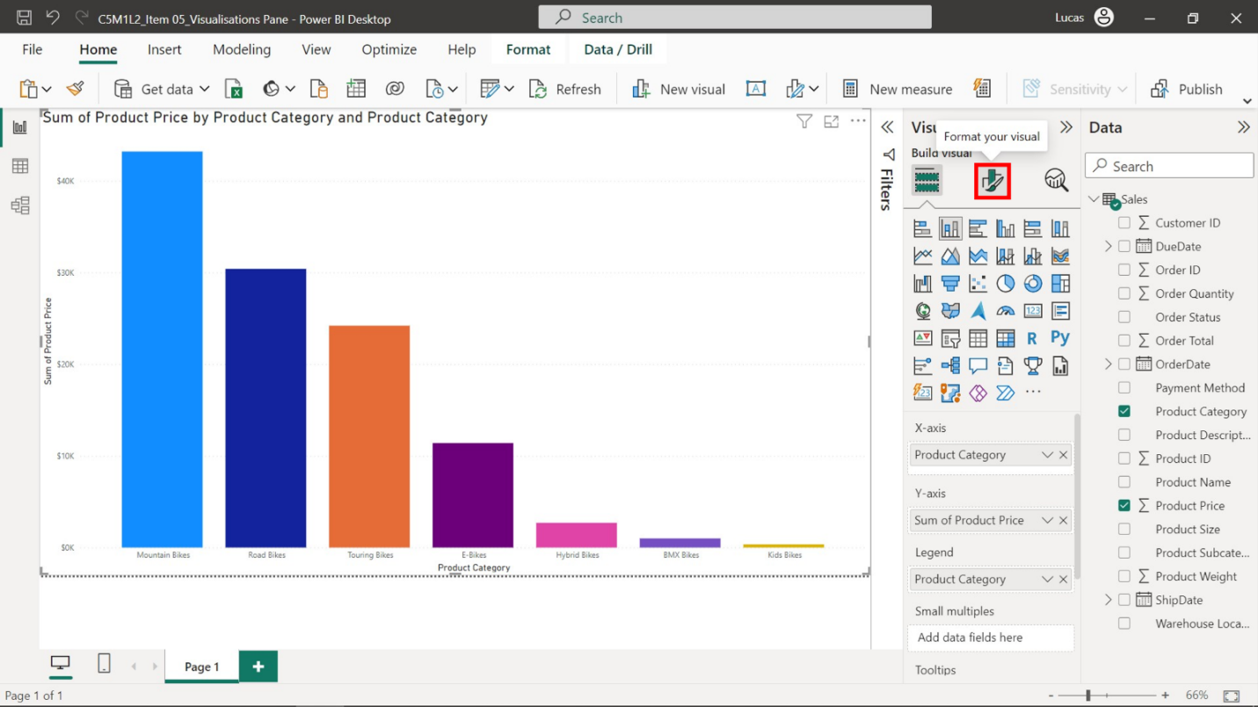

The **Format** section is a suite of options and controls that allows you to adjust the appearance of your visuals, including the color and size of your data points to the labels, titles, and background of your visualizations. Formatting your visuals helps ensure your visuals are accurate, aesthetically pleasing, and clear, which can dramatically improve insight, communication, comprehension, and engagement. Commonly used components of the Format section include:

* **General**: This is where you can set the horizontal and vertical position of the visualization on a grid (referred to as the X, Y position), its width and height, and aspect ratio, which maintains the original shape of the visualization when resizing. These parameters allow you to control where and how your data is displayed.

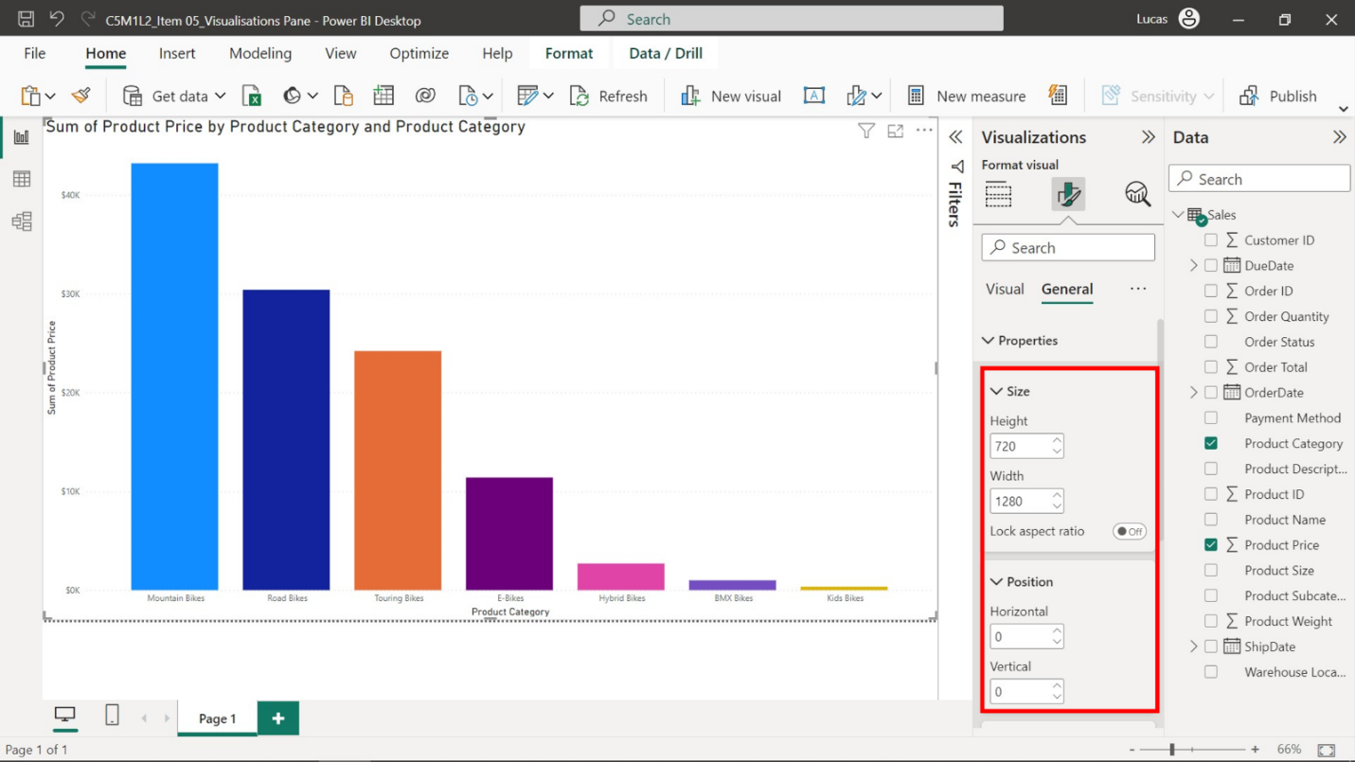

* **Colors**: This section lets you customize the color of individual data points. For example, you can use this component of the **Format** section to customize your visualizations using Adventure Works' corporate colors to maintain brand consistency.

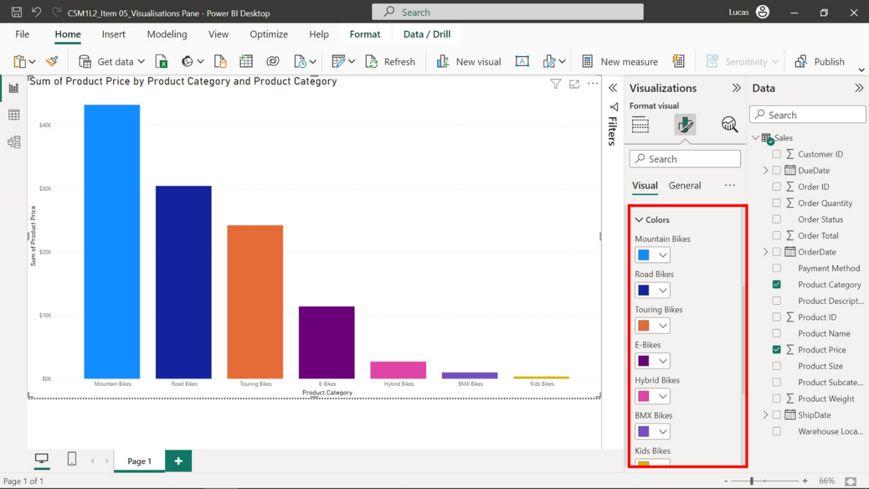

* **Legend**: A legend is a guide that helps explain the different data series or categories used in visualizations, often represented by different colors or shapes. The **Legend** options enable you to control and customize various legend elements such as its visibility, position, title, and label color.

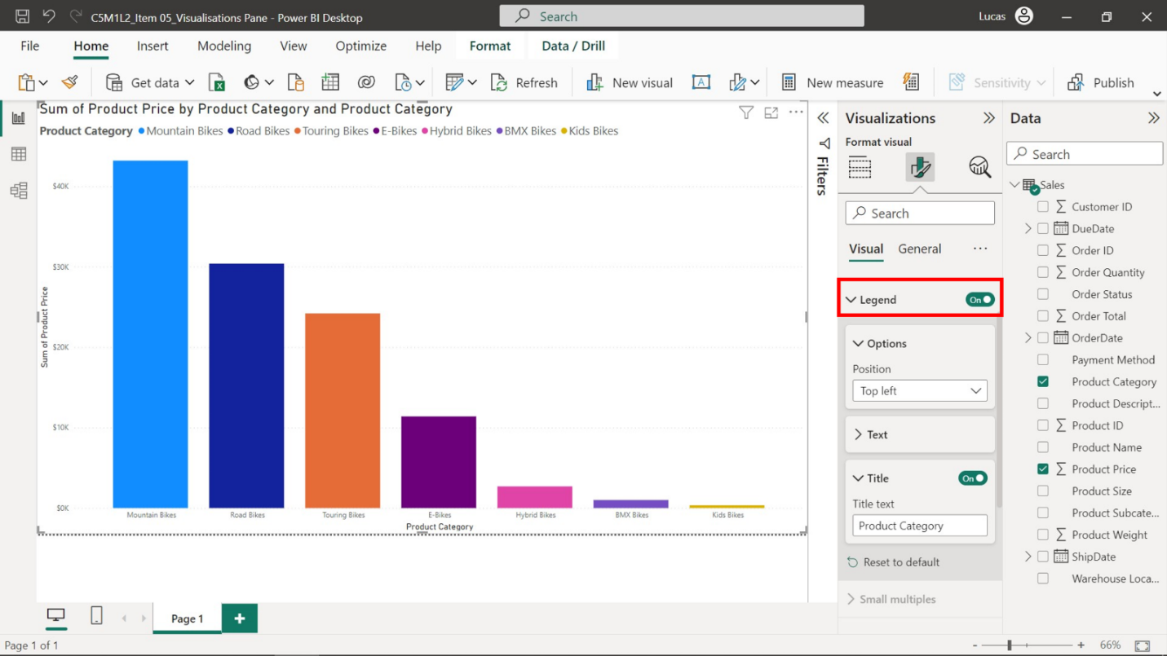

* **Data labels**: This is where you can adjust how you display data values on your chart. You can turn the data labels on or off, change their color, display units, decimal places, and so on. Data labels contribute to effective data visualization by providing precise values for data points, offering a more accurate view of the data, and enhancing understanding.

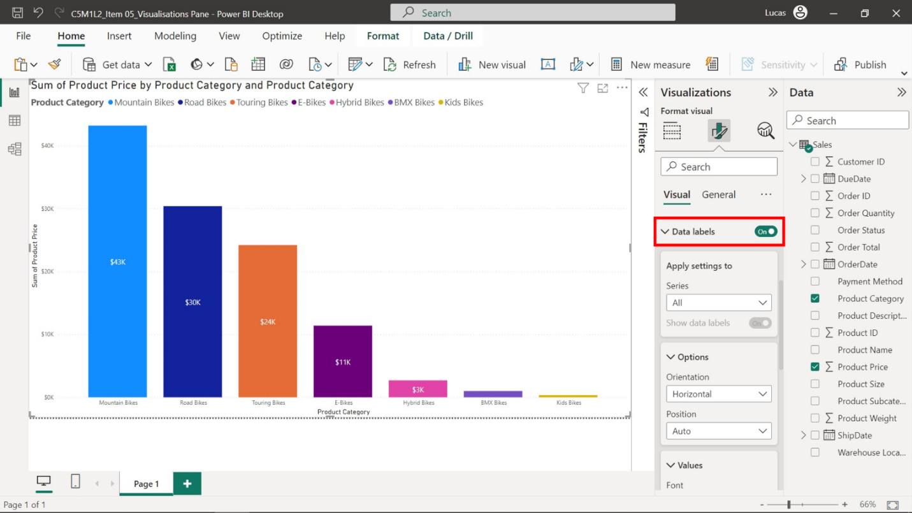

* **Title**: This section lets you adjust the visualization's title, including its text, font color, background color, and alignment.

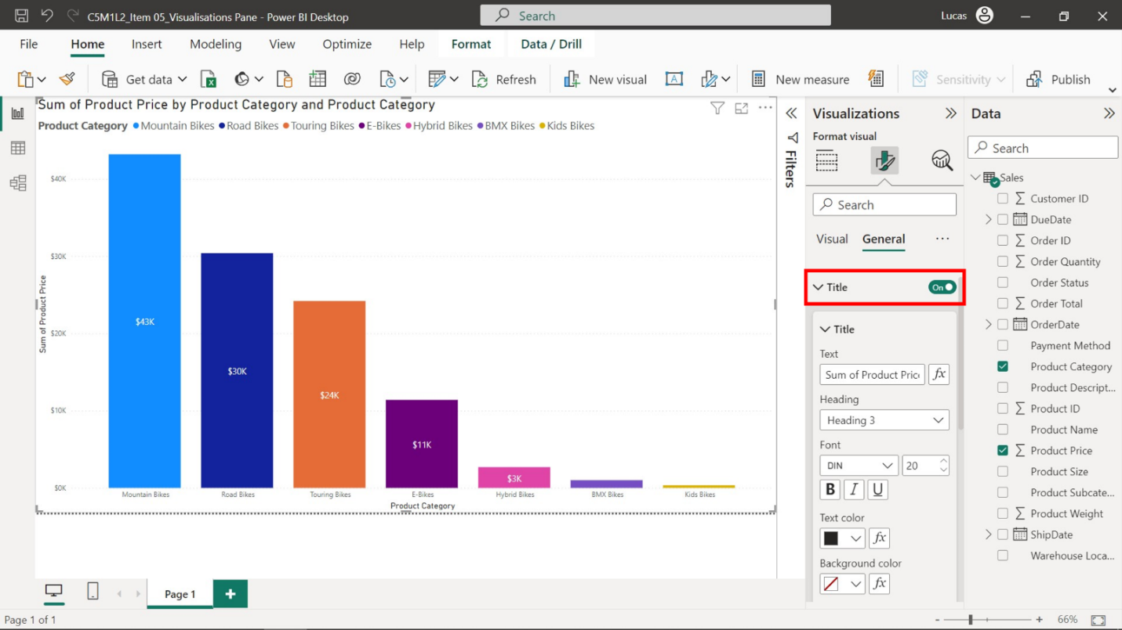

**Data**

The **Data** or **Fields** section in the **Visualizations** pane is where you define what data to display in your visualization and how you want to represent it. It is the driver of your data story, enabling you to select and categorize the data you want to analyze and present visually. It determines what data is available for your audience to examine and its presentation, impacting their understanding and interpretation of the data. The **Data** section is divided into two main parts: the **Fields list** and **Fields wells**.

* The **Fields list** contains all available data fields from your loaded dataset—the raw materials from which you'll craft your data story. For Adventure Works, this list could include data fields like **Product Category** and **Order Total**.

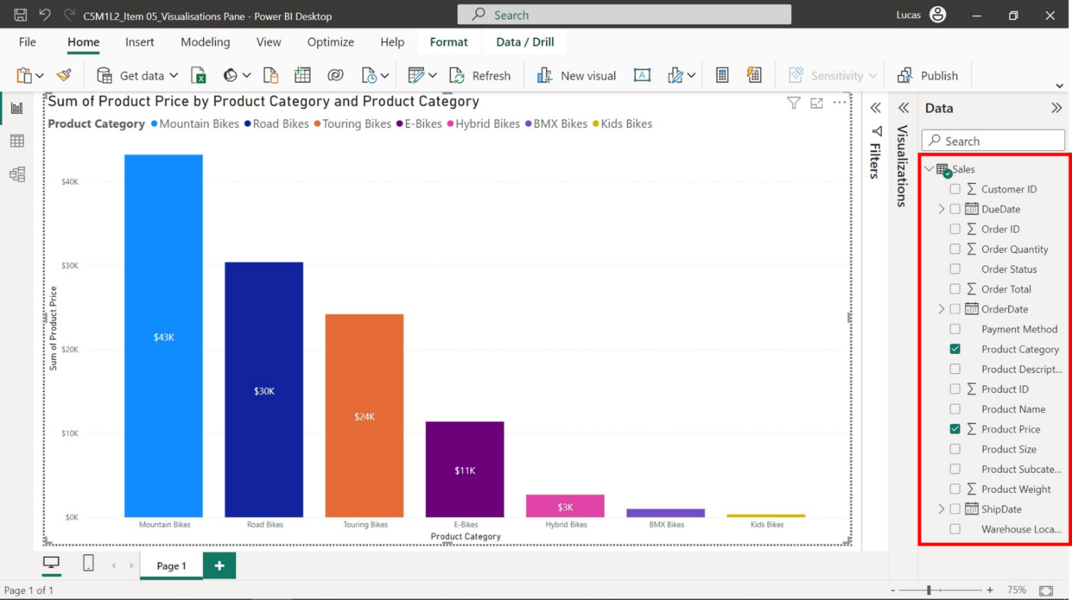

* In the **Fields wells**, you drag fields from the **Data** list to create your visualizations. There are typically four different wells: **Axis**, **Legend**, **Values**, and **Tooltips**, each serving a unique purpose.

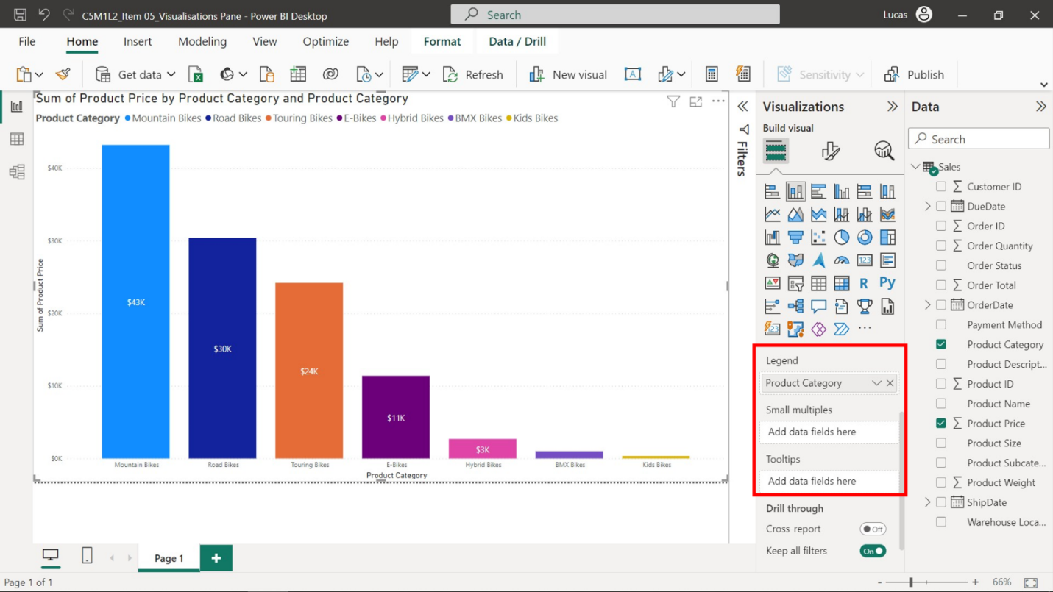

* **Axis**: This is where you define the **X-axis** and **Y-axis**. For example, if you're creating a column chart to compare the order total of different bike categories at Adventure Works, you would drag the **Product Category** field into the **X-axis** well and the **Order Total** field into the **Y-axis** well. Evaluating and contrasting order totals for each bicycle type can help inform Adventure Works' decisions, like marketing strategies and sales forecasts.

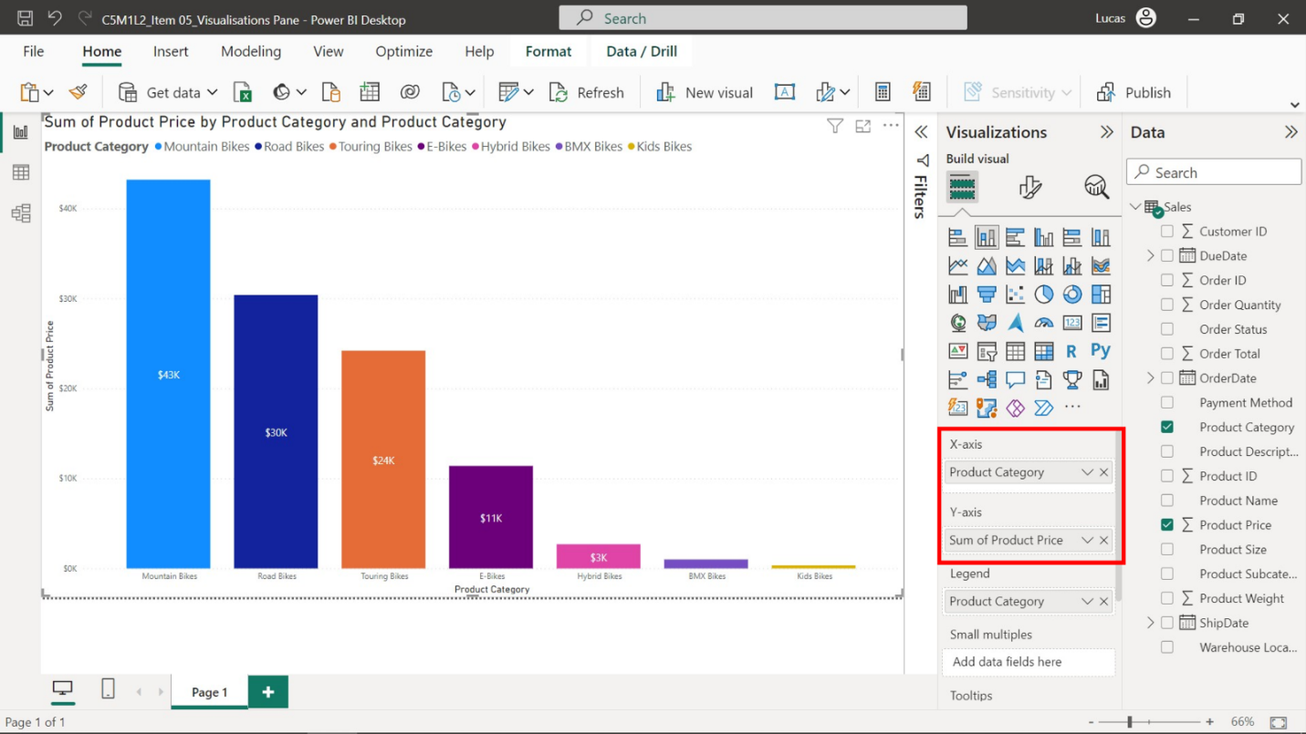

* **Legend**: If you're comparing multiple data series within one chart, for example, order totals of different bike types over several years, you can drag the field representing the different series (like **Year**) to the **Legend** well. This will create a legend distinguishing these series.

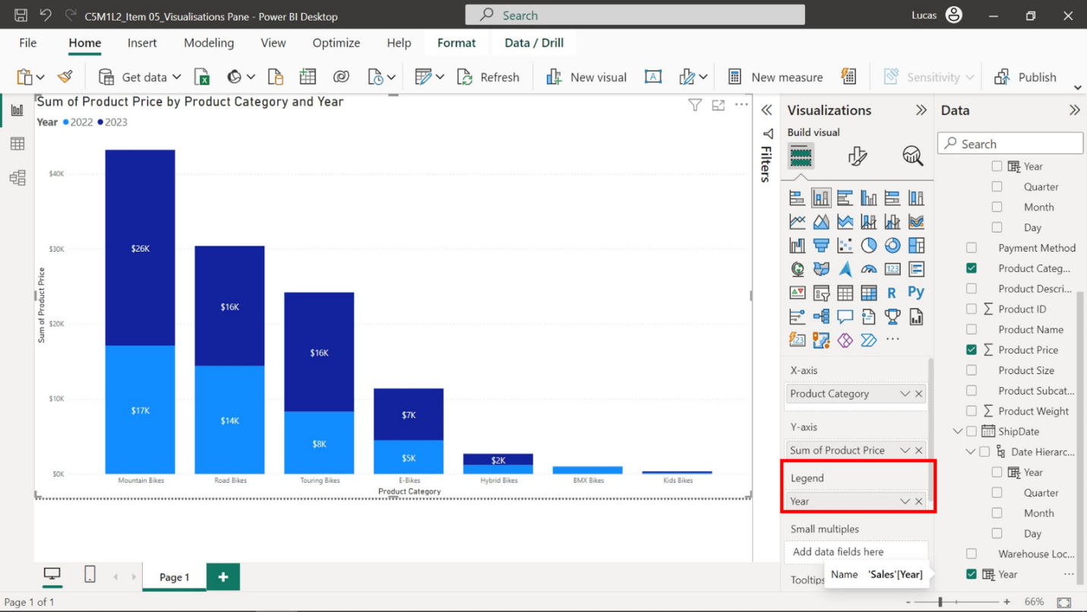

* **Tooltips**: Tooltips provide additional information when you hover over a data point in the visualization. For example, if you want to display the profit for each bike type when hovering over a bar in the chart, you would drag the **Profit** field into the **Tooltips** well.

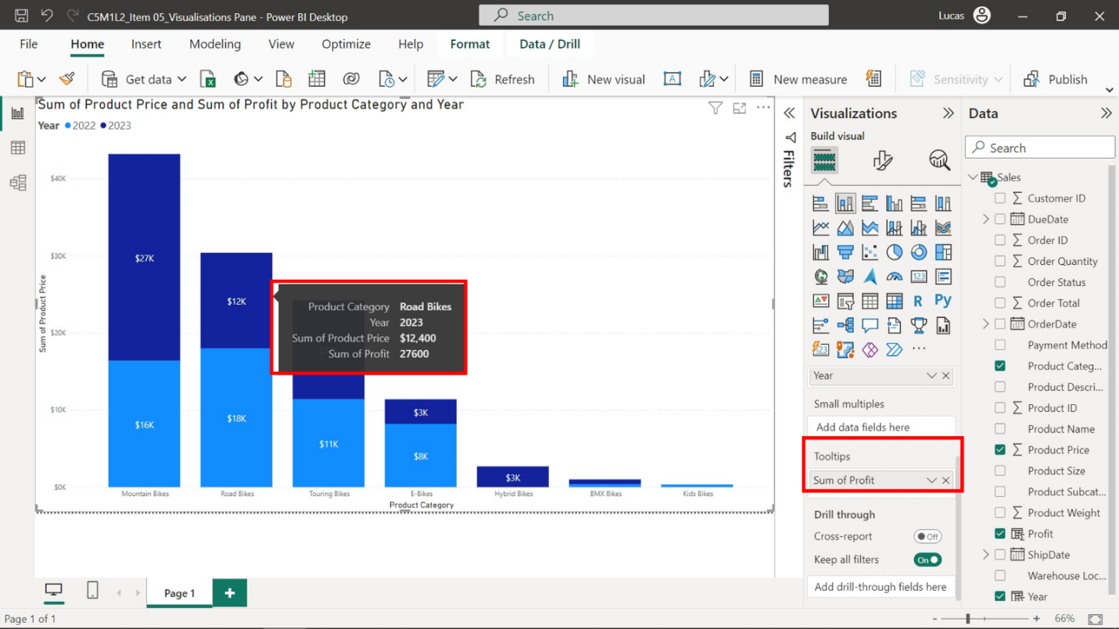

**Analyze**

The **Analyze** tab provides advanced analytical tools to extract meaningful insights from data beyond what's immediately visible in your charts or graphs. It is beneficial when you want to identify trends, calculate averages, or forecast future values to tell a richer data story. The primary elements of the Analyze tab include trend lines, average lines, and forecasting.

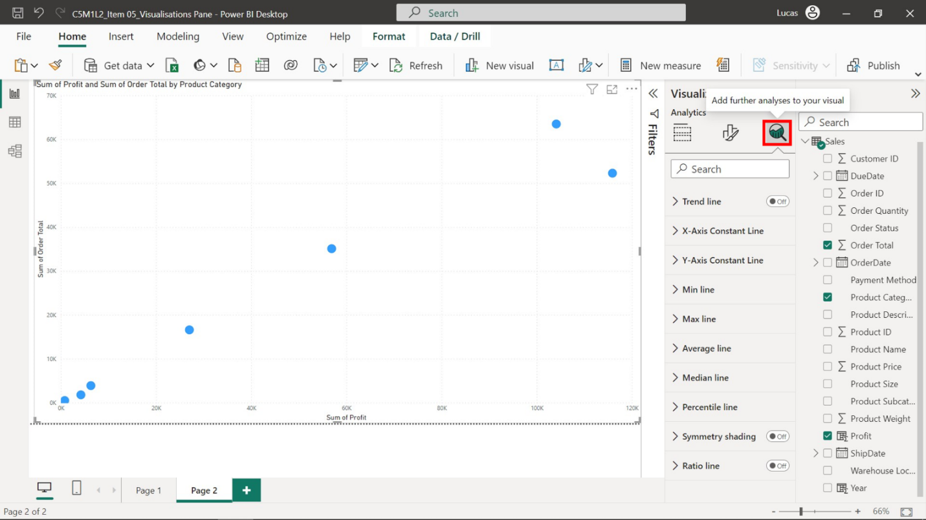

* **Trend line**: A trend line is a line overlaid on your chart revealing the overall direction of the data. This tool helps you visualize the trend in your dataset over time. For example, Adventure Works could use a trend line to observe the overall sales trend of their bicycles over the years.

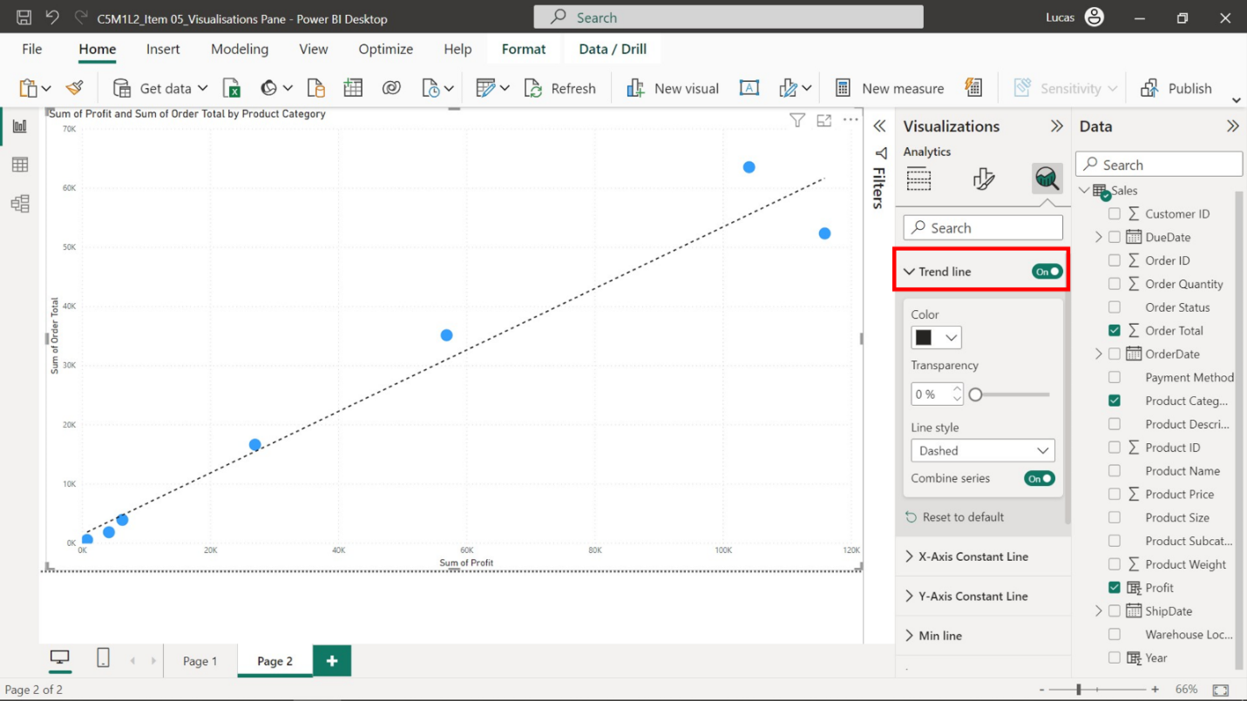

* **Average line**: Similar to trend lines, average lines enable you to visualize the average value of your data points. This is particularly useful when comparing individual data points against the overall average.

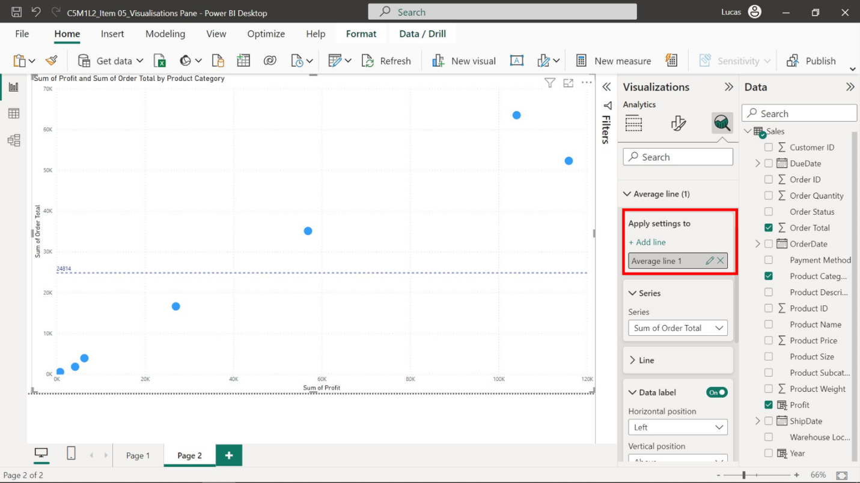

* **Forecast**: Forecasting is an advanced analytical tool that predicts future values based on your existing data. It uses statistical methods to analyze historical data and project future trends. Adventure Works, for instance, could use this feature to predict their future sales.

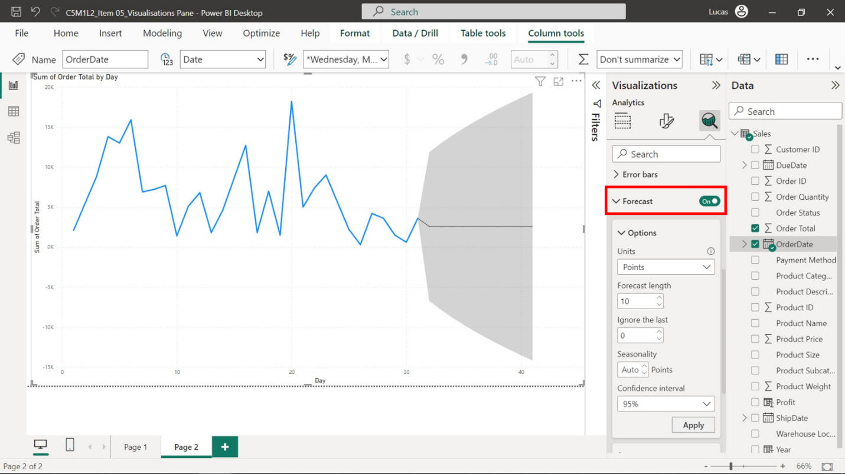

**Conclusion**

Power BI's **Visualization** pane is more than just a data tool—it's the translator that makes sense of a complex language of numbers, converting data into an understandable visual narrative that can influence crucial business decisions and inspire action. Learning about its structure and capabilities as you did in this reading will help you maximize its potential to deliver critical insights to decision-makers.